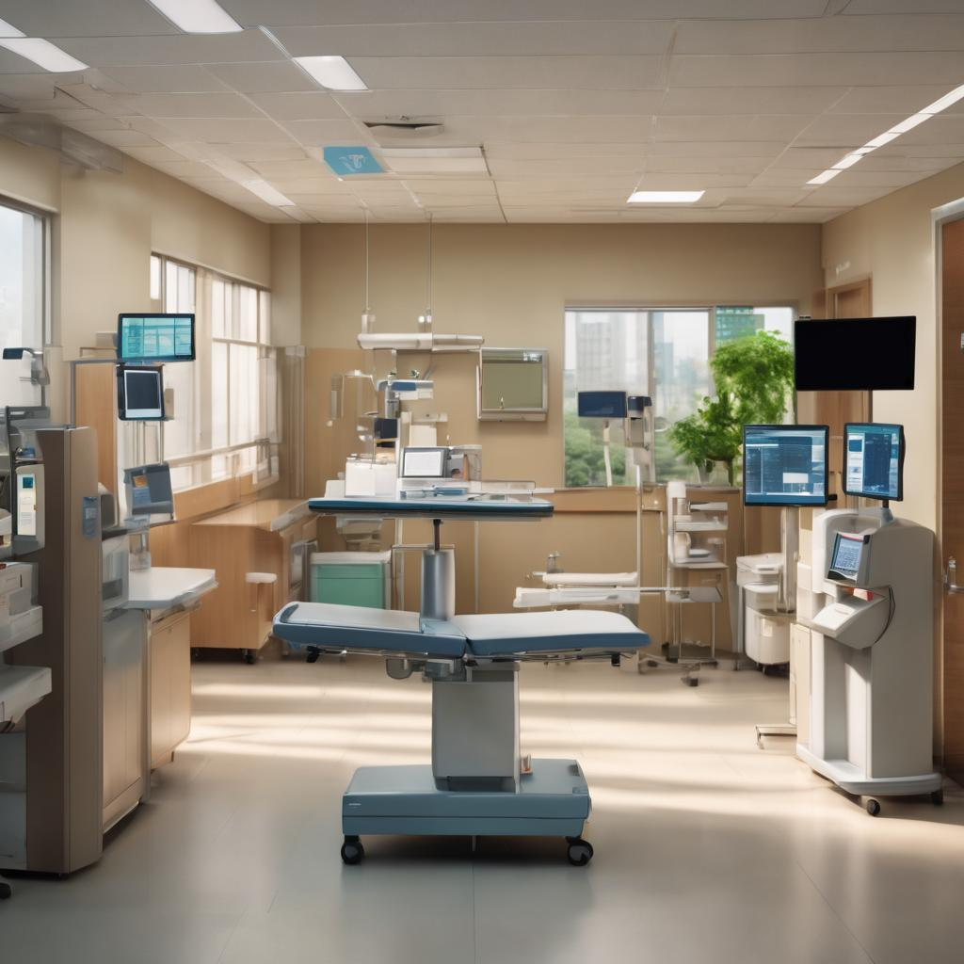

**INCREASING HOSPITAL POS COLLECTIONS**

Contents

Graphs: 2

Tables: 2

Introduction: 3

Exercise 1: 7

Exercise 2: 10

Exercise 3: 11

Exercise 4: 14

# Graphs:

Graph 1: Normality using Histogram bell curve 7

Graph 2: Normality using Anderson-Darling test 8

Graph 3: I-MR Chart of POS Payments 8

Graph 4: I-MR Chart of All Patient Payments 9

Graph 5: ANOVA using Individual Value Plot 11

Graph 6: Main Effects Plot 12

Graph 7: Fitted Line plot for regression analysis 13

# Tables:

Table 1: POS by Facility 5

Table 2: Payments trending 6

Table 3: Affinity Diagram 14

# Introduction:

Holistic Health Systems (HHS) operates 39 hospital facilities and clinics. The executive team has been reviewing key metrics over the last year and identified a need to improve Point of Service Collections, simply known as POS (pronounced "P-O-S"). POS is a patient payment that is received within 7 days of discharge. Increasing POS is important for HHS because hospitals are 60% less likely to receive payment once the patient leaves the hospital. The cost of collecting on the patient’s account continues to go up while the chance of actually collecting payment goes down if there is a delay in collecting the payment after the patient’s discharge. Therefore, it is better to not delay collecting the payment.

Increasing POS reduces bad debts, provides a better cash position, reduces expenses, and increases patient satisfaction when conducted properly.

POS is calculated by dividing POS payments by the total patient cash collected. HHS has identified the industry median benchmark for POS as 13.6% and the top 10% POS benchmark as 41.4%. HHS’s current POS performance is 35.6%, and the executive team has determined that a 5-percentage point increase is needed to stay competitive (target = 40.6%). A Lean Six Sigma team was formed.

POS is a metric that heavily relies on the Patient Access team or PA. PA is responsible for several tasks—patient scheduling, registration, and financial clearance. The "scheduling" tasks are typically completed by a centralized PA team for multiple hospital facilities. During scheduling, PA reps receive a doctor’s order for a patient. The order is like a permission slip for specific medical services the doctor deems necessary. The doctor or even the patient related to the order can call scheduling to reserve an appointment for the services that correspond to what is written in the order. PA reps need to verify that the order is complete and accurate, coordinate time for services, and provide patients with pre-service instructions. After the patient’s information is logged into the scheduling system, it will be queued up for the PA registration team to complete the registration process. The PA will call the patient and confirm their identity and collect demographics such as address, family, emergency contact, etc. The patient's health insurance provider(s) will also be confirmed as part of the PA registration process. PA registration can be completed at a hospital facility or by a centralized team. Lastly, PA Financial Clearance will verify patient health benefits to ensure they exist and to determine if the procedure or service for the patient is covered. If authorization is required, the PA Financial Clearance will request authorization for services from the patient’s health insurance provider. Services performed without authorization lead to rejected claims. Also, during PA Financial Clearance, the PA rep will counsel the patient about their liability (how much their insurance provider says they need to pay for the services) and collect the payment. Any payment received is considered POS since it’s before 7 days post-discharge. Financial clearance can also be performed at the hospital facilities or by a centralized team.

Summary patient cash data for HHS’s 39 hospital facilities for a year is presented in Table 1. The table also indicates if the PA team for each facility is centralized or not.

Table 2 provides an overall monthly trend for POS performance.

The team identified the facilities with POS performance above the target and researched the activities they have in place, hoping to find commonalities or key drivers. They are:

* Ensure proper patient education on benefits and liability
* Ask for payment
* Have a financial counselling policy
* Reduce the number of patients that leave without financial clearance
* Have accurate tools to help estimate patient liability or responsibility
* Utilize devices that allow patient collections at the patient’s bedside

|  |  |  |  |  |
| --- | --- | --- | --- | --- |
| **Table 1: 2015 POS by Facility** | | | | |
| **Facility** | **POS Payments** | **All Patient Payments** | **POS%** | **Centralized Teams** |
| **FVR** | $13,72,015 | $68,60,076 | 20% | Yes |
| **LAK** | $13,01,746 | $33,48,748 | 39% | Yes |
| **PLA** | $29,64,730 | $68,54,164 | 43% | Yes |
| **CGH** | $6,25,428 | $17,09,452 | 37% | Yes |
| **FLO** | $8,49,646 | $21,41,211 | 40% | Yes |
| **DEL** | $23,24,347 | $78,24,857 | 30% | Yes |
| **GSM** | $26,21,784 | $97,10,312 | 27% | Yes |
| **PBG** | $17,13,107 | $60,62,173 | 28% | Yes |
| **SMH** | $59,36,564 | $1,03,55,241 | 57% | Yes |
| **HIA** | $12,15,112 | $22,50,807 | 54% | Yes |
| **PGH** | $22,34,134 | $53,95,099 | 41% | Yes |
| **MAN** | $13,11,286 | $36,11,438 | 36% | Yes |
| **MOD** | $29,97,636 | $74,94,091 | 40% | Yes |
| **WBO** | $22,73,401 | $87,43,852 | 26% | Yes |
| **LOM** | $23,58,653 | $81,33,287 | 29% | Yes |
| **BAR** | $14,57,038 | $52,86,184 | 28% | Yes |
| **DES** | $26,76,236 | $95,81,654 | 28% | Yes |
| **IND** | $10,76,377 | $29,79,026 | 36% | Yes |
| **DHW** | $21,45,483 | $52,49,186 | 41% | Yes |
| **ECH** | $24,28,480 | $78,33,806 | 31% | Yes |
| **HHH** | $22,53,084 | $70,80,683 | 32% | Yes |
| **SCH** | $5,48,628 | $17,39,024 | 32% | Yes |
| **GBH** | $24,55,353 | $72,62,268 | 34% | Yes |
| **BMC** | $34,86,532 | $1,39,46,130 | 25% | Yes |
| **CYF** | $45,34,470 | $1,07,96,357 | 42% | No |
| **DHF** | $24,16,085 | $46,24,894 | 52% | No |
| **FRH** | $21,82,243 | $69,29,016 | 31% | No |
| **HNM** | $56,00,722 | $1,24,46,048 | 45% | No |
| **LPX** | $33,79,727 | $91,34,398 | 37% | No |
| **NMC** | $19,46,885 | $43,78,487 | 44% | No |
| **PMC** | $28,85,804 | $91,88,848 | 31% | No |
| **PPH** | $19,69,620 | $39,39,240 | 50% | No |
| **PRV** | $60,15,807 | $1,22,53,503 | 49% | No |
| **SES** | $19,40,017 | $49,71,199 | 39% | No |
| **SFH** | $32,54,250 | $78,50,558 | 41% | No |
| **SIE** | $30,51,755 | $69,99,804 | 44% | No |
| **SRM** | $26,58,292 | $1,09,09,840 | 24% | No |
| **SVM** | $16,06,482 | $65,73,344 | 24% | No |
| **TWI** | $12,97,858 | $52,25,755 | 25% | No |

Table 1: POS by Facility

|  |  |  |
| --- | --- | --- |
| **Table 2: 2015-2016 Payments Trending** | | |
|  | **POS Payments** | **All Patient Payments** |
| **Jan-14** | $81,98,401 | $2,21,05,614 |
| **Feb-14** | $64,09,335 | $2,04,49,785 |
| **Mar-14** | $74,52,507 | $2,53,57,473 |
| **Apr-14** | $78,53,058 | $2,43,20,414 |
| **May-14** | $72,77,931 | $2,48,15,250 |
| **Jun-14** | $89,75,992 | $2,03,09,240 |
| **Jul-14** | $73,49,353 | $2,49,04,346 |
| **Aug-14** | $68,04,829 | $2,33,49,092 |
| **Sep-14** | $78,98,465 | $2,08,29,620 |
| **Oct-14** | $78,88,816 | $1,85,06,142 |
| **Nov-14** | $58,34,679 | $1,73,86,881 |
| **Dec-14** | $90,21,591 | $1,86,59,237 |
| **Jan-14** | $87,17,536 | $1,89,56,764 |
| **Feb-14** | $66,23,228 | $1,90,08,749 |
| **Mar-15** | $76,96,772 | $2,29,71,163 |
| **Apr-15** | $83,12,773 | $2,34,37,612 |
| **May-15** | $90,28,170 | $2,13,58,646 |
| **Jun-15** | $74,36,050 | $2,21,68,016 |
| **Jul-15** | $78,52,119 | $2,19,71,590 |
| **Aug-15** | $69,33,100 | $2,36,50,610 |
| **Sep-15** | $86,23,086 | $2,68,60,403 |
| **Oct-15** | $78,50,627 | $2,13,46,585 |
| **Nov-15** | $76,91,110 | $2,30,04,295 |
| **Dec-15** | $86,02,245 | $2,29,39,623 |

Table 2: Payments trending

# Exercise 1:

* Process Stability Using the data given in Table 2, determine if the POS performance is stable using a control chart.
* Explain why you used the type of control chart you selected.

**Before checking the stability of the data, normality should be checked.**

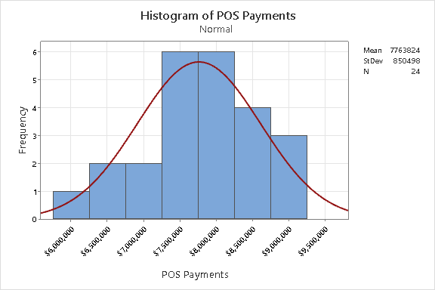

Graph 1: Normality using Histogram bell curve

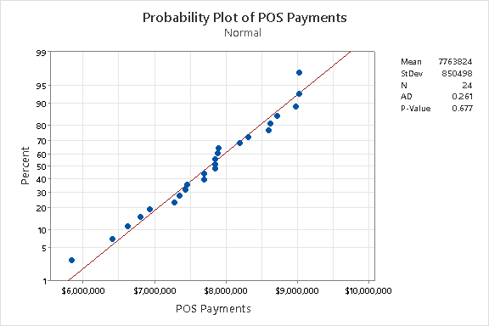

Graph 2: Normality using Anderson-Darling test

Provided Data is checked for normality through the Histogram and Anderson-Darling test for POS Payments --- Provided Data is Normal (P-Value >0.05) P-Value is 0.677.

Now, check for the Stability.

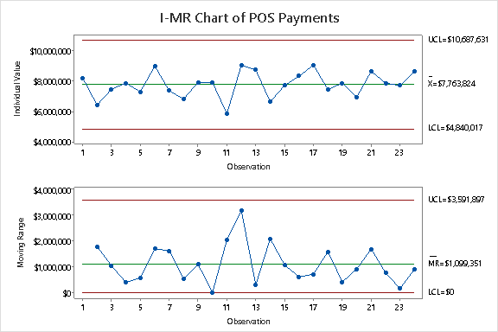

Graph 3: I-MR Chart of POS Payments

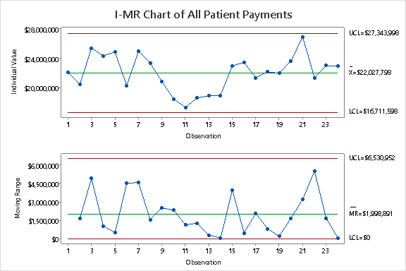

Graph 4: I-MR Chart of All Patient Payments

* The Individual Value plot of the I-MR charts suggests that the POS performance is stable with time for both POS Payments and All Patient payments. However, the Moving Range chart suggests some variations in the process. Specifically, the MR Chart for POS payments reveals an out-of-control process for the month of October as the point lies on the LCL. Furthermore, the MR Chart reveals that there was a sharp rise in the average MR for the month of December. This calls for an investigation. Also, the MR Chart for Patient payments indicated an out-of-control process for the months of Feb-15 and Dec-15.
* Type of Control Chart: I-MR Chart – This is used because this chart is most suitable for data that is continuous with a subgroup size of one.

# Exercise 2:

Scope Opportunity Using the data given in Table 1, how would you scope the focus area of the project?

* From the provided project details understand Holistic Health Systems (HHS) operates 39 hospitals and clinics and the current POS performance of HHS is 35.6% and executed team has determined that a 5%-point increase is required to state HHS' competitive target (40.6%).
* As data provided in Table 1 (2015 POS by facility) shows that out of 39 hospitals /clinics 13 facilities are above the POS targeted % (40.6%).
* So, the Scope to set these 13 facilities above the targeted POS% as a control benchmark and the rest of the facilities needs to be analysed/investigated for POS% increase.
* Hypothesis testing needs to be conducted for facilities with POS percentage Above the targeted level have the centralized team or not.
* Testing should be conducted to check the association between the POS collection team and centralized team and to check association is practically significant or not.

# 

# Exercise 3:

Testing a Theory Use the data from Table 1 and conduct a hypothesis test to determine if centralized teams impact POS collections.

Checking if centralized teams impact POS collections. This is checked using One-way ANOVA

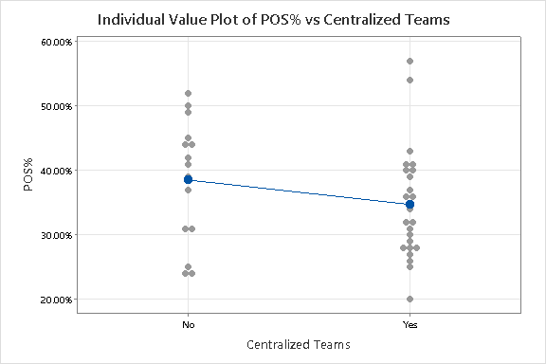

Graph 5: ANOVA using Individual Value Plot

If you see the average and difference between the Centralised and not centralised. Here, it clearly says there is some difference and they are not the same.

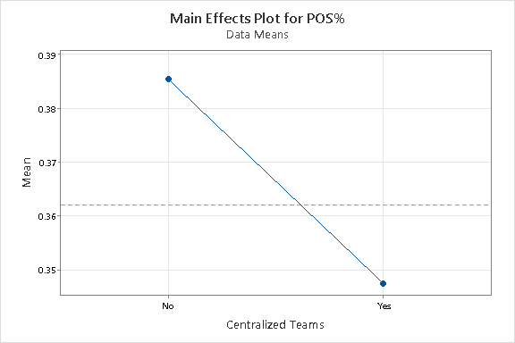

Graph 6: Main Effects Plot

This graph shows us that centralised teams to a very large extent impact POS collection.

**Correlation test:**

Ho: r = 0; no correlation

H1: r ≠ 0; there is a correlation

Pearson correlation of CT coded and POS Payments = -0.331

**P-value = 0.040**

A Pearson correlation r = -0.331 implies there is a weak negative correlation between centralised teams and POS Collections. A P-value of 0.04 indicates that this association is statistically significant and so we reject the null hypothesis.

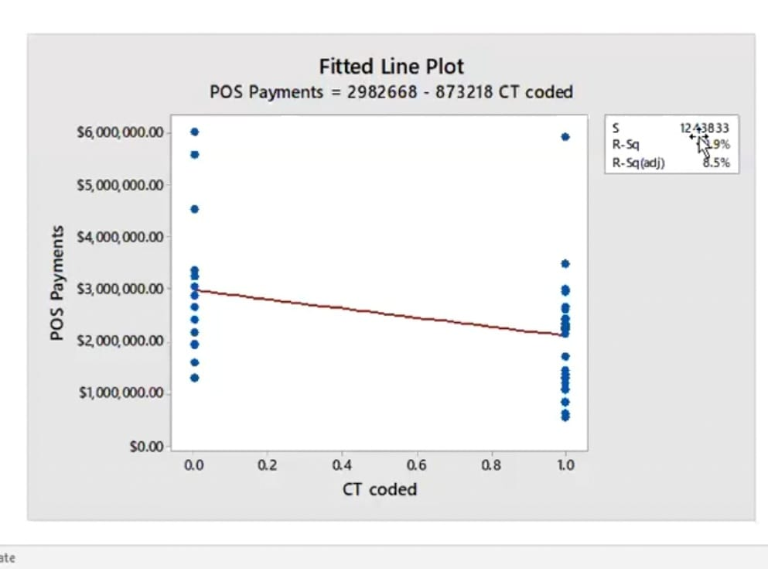

Graph 7: Fitted Line plot for regression analysis

Simple Linear regression is further done to check whether there is a correlation or not.

It is done between POS payments and CT codes.

The regression equation is:

POS Payments = 2982668 – 873218 CT codes

S = 1243833 R-Sq = 10.69% R-Sg(adj) = 8.5%

Analysis of Variance

Source DF SS MS F P

Regression 1 7.03855E+12 7.03855E+12 4.55 0.040

# Exercise 4:

Solution Categories Based on the information provided, what could be the affinity categories for the key drivers that impact POS performance?

|  |  |  |
| --- | --- | --- |
| **POS Performance** | | |
| Finance | Team | Environment |
| Have a financial counselling policy | Ask for Payment | Have accurate tools to help estimate Patient Liability or Responsibility |
| Have proper patient education on the benefits and liability | Utilise devices that allow patient collections at the patient's bedside |
| Reduce the number of patients that leave without financial clearance |

Table 3: Affinity Diagram